**Lab Program 1**:

Implement three nodes point – to – point networks with duplex links between them. Set the queue size, vary the bandwidth and find the number of packets dropped.

**Topology**

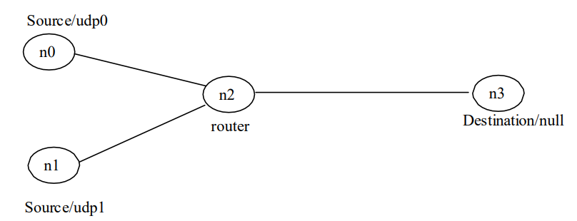

**#Create Simulator object**

set ns [new Simulator]

**#Open trace file**

set nt [open lab1.tr w]

$ns trace-all $nt

**#Open namtrace file**

set nf [open lab1.nam w]

$ns namtrace-all $nf

**#Create nodes**

set n0 [$ns node]

set n1 [$ns node]

set n2 [$ns node]

set n3 [$ns node]

**#Assign color to the packet**

$ns color 1 Blue

$ns color 2 Red

**#label nodes**

$n0 label "Source/udp0"

$n1 label "Source/udp1"

$n2 label "Router"

$n3 label "Destination/null"

**#create links, specify the type, nodes, bandwidth, delay and ARQ algorithm for it**

$ns duplex-link $n0 $n2 10Mb 300ms DropTail

$ns duplex-link $n1 $n2 10Mb 300ms DropTail

$ns duplex-link $n2 $n3 100Kb 300ms DropTail

**#set queue size between the nodes**

$ns queue-limit $n0 $n2 10

$ns queue-limit $n1 $n2 10

$ns queue-limit $n2 $n3 5

**#create and attach UDP agent to n0, n1 and Null agent to n3**

set udp0 [new Agent/UDP]

$ns attach-agent $n0 $udp0

set udp1 [new Agent/UDP]

$ns attach-agent $n1 $udp1

set null3 [new Agent/Null]

$ns attach-agent $n3 $null3

**#attach Application cbr to udp**

set cbr0 [new Application/Traffic/CBR]

$cbr0 attach-agent $udp0

set cbr1 [new Application/Traffic/CBR]

$cbr1 attach-agent $udp1

**#set udp0 packet to red color and udp1 packet to blue color**

$udp0 set class_ 1

$udp1 set class_ 2

**#connect the agents**

$ns connect $udp0 $null3

$ns connect $udp1 $null3

**#set packet size and interval for cbr1**

$cbr1 set packetSize_ 500Mb

$cbr1 set interval_ 0.005

**#finish procedure**

proc finish { } {

global ns nf nt

$ns flush-trace

exec nam lab1.nam &

close $nt

close

$nf

exit 0

}

$ns at 0.1 "$cbr0 start"

$ns at 0.1 "$cbr1 start"

$ns at 10.0 "finish"

$ns run

**AWK file**

BEGIN { count=0;

}

{

if ($1=="d")

count++

}

END{

printf("Number of packets dropped is = %d\n", count);

}